**THE AFFILIATED PARISHES OF St ANNE,**



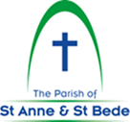

**ST BEDE & ST BRIDGET**

**Bulletin – 15 January 2023**

**WEEKDAY MASS SCHEDULE**

**St Anne’s**: Wednesday at 9am (28/12/22 – 25/1/23)

**St Bede’s**: Tuesday, Thursday, Friday at 9am (27/12/22 – 21/1/23); Saturday at 9am

**St Bridget’s**: First Wednesday of the month at 10.30am

and every first Friday of the month at 8:30am.

**ALL WEEKDAY MASSES FROM CHRISTMAS TO AUSTRALIA DAY WEEKEND WILL BE AT 9.00AM (both St Anne’s and St Bede’s.)**

**WEEKEND MASSES**

**Saturday**

**St Anne’s**: 5pm

**St Bede’s**: 6pm

**St Bridget’s**: 5pm

**Sunday**

**St Anne’s**: 10:30am

**St Bede’s**: 9am, 11am

**St Bridget’s**: 10am

**St Joachim’s**: 8:30am

**St Anne’s & St Bede’s**

**Parish Office:** 1 Severn St, Balwyn North

**Office Hours:** Tuesday & Friday 9am-12pm; Wednesday & Thursday 9am-3.30pm

**Phone:** 9401 6355

In case of emergency 9401 6368

**E-mail:** [balwynnorthkeweast@cam.org.au](mailto:balwynnorthkeweast@cam.org.au)

**Website:** parishofstanneandstbede.org.au

**St Bridget’s**

**Parish Office:** 48 Sweyn St, Balwyn North

**Office Hours: Thursday 9am-12pm**

**Phone:** 9857 6395

**E-mail:** [greythorn@cam.org.au](mailto:greythorn@cam.org.au)

**Website:** stbridgetsgreythorn.org.au

**The Sacrament**

**of Reconciliation**

*St Bede’s: after 9am Mass Saturday*

*St Anne’s: 4.30pm Saturday*

*St Bridget’s: 4.30pm Saturday*

**Exposition of the Blessed Sacrament***St Bede’s: after 9.15am Mass Friday*

**Baptisms and Weddings**

*Please contact parish office*

**PARISH STAFF**

**Parish Priest**: Fr John Salvano

**Assistant Priest**: Fr Vinh Do

**Priest in Residence:** Fr Kevin Lenehan

**Parish Secretary for St Anne’s & St Bede’s**

Sara Lanza

**Parish Secretary for St Bridget’s**

Mario Landini

**Finance Officer:** Kristina Slavec

**Flower arranging Workshop**

A flower arranging workshop will be

hosted by **St Bridget’s Greythorn** on

**Saturday 4th February at 10am**.

All invited, so come along and get

ideas on how to create stunning floral

arrangements for all occasions.

Flyers available at the back of Churches.



***SAFETY OF CHILDREN AND ALL VULNERABLE PEOPLE****:*

We hold the care, safety and wellbeing of children and all vulnerable people as a central and fundamental responsibility of our parish. The Parish Statement of Commitment and Reporting Process are on display in all churches and all Parish Policies are available on the website.

**Patron Saint of our Parish**

**St Bridget’s Feast Day** will be

celebrated on **Sunday 5 February**

with Mass at 10.00am followed by

morning tea in the parish hall.

All invited, please bring a plate.

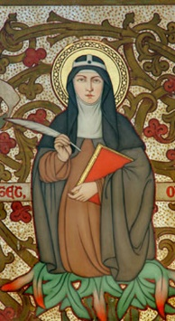

**SAVE THE DATE**

*The Affiliated Parishes Picnic will be held on* ***Sunday March 5th 2023 at***

***St Bridget’s****. More details to follow.*

|  |  |  |  |  |  |  |  |
| --- | --- | --- | --- | --- | --- | --- | --- |
| **2022 Annual Statistics** | | | | | | **2022 Mass Count**  **(Average Weekend**  **Mass Attendance)** | |
|  | **BAPTISMS** | **FIRST HOLY COMMUNIONS** | **CONFIRMATIONS** | **MARRIAGES** | **FUNERALS** |  | |
| **Balwyn North**  **Kew East** | 23 | 68 | 86 | 2 | 27 | **Balwyn North**  **Kew East** | 455 |
| **Greythorn** | 1 | 8 | - | - | 7 | **Greythorn** | 121 |

**Parish Prayer Groups**

**St Anne’s Divine Mercy Prayer Group**

* **Weekly meetings** (Tuesdays at 6.20pm at St. Anne's) **resume on Tuesday 31st January 2023**.
* **Monthly Mass** (1st Tuesday of the month, 7pm) **resumes on Tuesday 7th February 2023.**

**St Bridget’s Weekly Prayer meetings**

Meditation and Scripture reflection meetings will have a break during Christmas and New Year.

* **Meditation group** (Wednesdays: 9.30 – 10.30am) **will meet face-to-face in January 2023.**
* **Scripture Reflection** (Sundays: 8.30 – 9.30am) **will resume in mid-January 2023.**

Contact: Susie on [susiehii.hc@gmail.com](mailto:susiehii.hc@gmail.com) or 0410981979

**New Parishioners**

If you are new to the Parish – Welcome! Please fill out a Census card, which can be obtained from the office.

**Parish Bulletin**

If you do not currently receive the Bulletin via email and would like to, please provide the office with your email address.

**VOLUNTEER OPPORTUNITES**

We are in need of **Lectors** for the **6pm** and **11am** Masses at **St Bede’s**. If you can help out as Lector please contact the St Anne & St Bede Parish Office.

**PRE-SACRAMENTAL PROGRAM FOR CHILDREN NOT IN A CATHOLIC SCHOOL -** Classes will be held in May. Further information will be placed in the Bulletin and on the Parish websites soon.

**Special Ministers are requested to wear a face mask when serving at Mass.**

**ROSTERS FOR 22 JANUARY 2023**

|  |  |  |
| --- | --- | --- |
| ST ANNE’S  ***Saturday 5pm***  *Lector: M Fawcett*  *Special Minister: M Kiley*  ***Sunday 10:30am****Lector: G O’Keefe*  *Special Minister: J Collins*  ST JOACHIM’S  ***Sunday 8:30am***  *Lector: J Connell* | St BEDE’S  ***Saturday 6pm***  *Lector: V Tran*  *Special Minister: R Pingitore*  ***Sunday 9am***  *Lector: R Mahoney*  *Special Minister: J Comito*  ***Sunday 11am***  *Lector: R Unkles*  *Special Minister: Anthony DiStasio* | ST BRIDGET’S  ***Saturday 5pm***  *Lector: V Borg*  *Special Minister: V Tozer*  ***Sunday 10am***  *Lector: V Brunton*  *Special Minister: J Hocking*  ***Visiting the Sick***  *A Mariampillai* |

|  |  |
| --- | --- |
| ***2nd Sunday in***  ***Ordinary Time, Year A 15 January 2023*** | ***First Reading:*** *Isaiah 49:3, 5-6* |
| ***Responsorial Psalm:*** *Psalm 39:2, 4 7-10*  ***R/Sung:*** *Here I am, Lord;*  *I come to do your will****.*** |
| ***Second Reading:*** *1 Corinthians 1:1-3* |
| ***Gospel Acclamation:*** *John 1:14,12*  ***Alleluia, alleluia!***  *The Word of God became flesh and dwelt among us. He enabled those who accepted*  *him to become the children of God.*  ***Alleluia!*** |
| ***Gospel:*** *John 1:29-34* |

***Mass Hymns***

***Entrance***

O Christ The Great Foundation (GA 483)

***Offertory***

Baptised In Water

(GA 179)

***Communion***

Come Down O Love Divine (GA 375)

***Recessional***

All Creature Of Our God (GA 395)

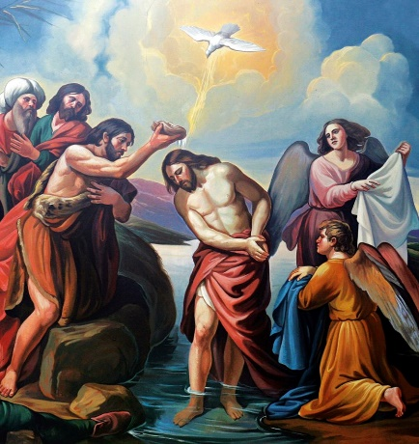



*We pray for those who have died recently especially* ***George Cardinal Pell, Maria Oanh Bui, Ged White, Moyna O’Donnell, Ian Stuart*** *and* ***Ricky (Jaoa Baptista) Hong*** *and for all whose anniversaries*

*occur* *at this time especially* ***Giovanni, Gregoria & Sonia Pingitore*** *and* ***Ersila Di Domizio.***

***May God reward their faith and lead them to the fullness of eternal life.***